How Virtual Prototyping Accelerates Development of Electric Vehicles

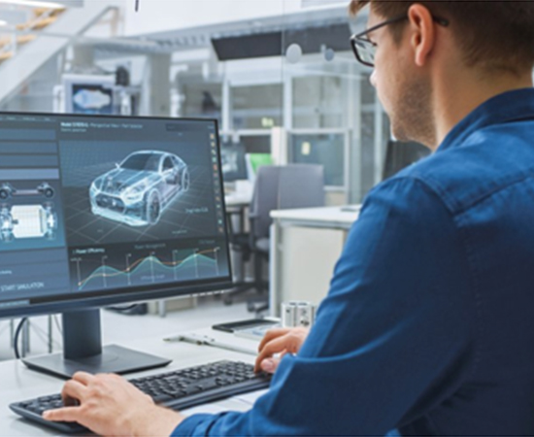

As the demand for electric vehicles grows, there is a need for EV manufacturers to bring new models to the market as fast as possible. However, the traditional method of developing automobiles may not be fast enough, and the companies that evolve the quickest get to dominate the market. This is where virtual prototyping comes in. What is virtual prototyping, and how can it accelerate electric vehicle development? The rest of this article answers these questions and more. However, we will start with the future of electric vehicles.

# What does the future hold for electric vehicles?

The short answer is that there will be more EVs in the future. This is evident from trends in battery-powered mobility, which has witnessed a revolution right before our eyes. For example, [in Norway, electric vehicles accounted for 83.7 percent](https://thedriven.io/2022/02/03/norways-stunning-new-ev-numbers-84-of-new-car-sales-in-january-all-electric/#:~:text=Nevertheless%2C%20electric%20vehicles%20accounted%20for,53%25%20recorded%20for%20January%202021.) of all new cars registered in the first month of 2022. This was a significant jump from 53 percent for the same period in 2021.

In a move that will only boost EV adoption, [the UK has banned the sales of new ICE light vehicles from 2030](https://www.theguardian.com/business/2021/mar/15/car-industry-lobbied-uk-government-delay-ban-petrol-diesel-cars#:~:text=The%20government%20announced%20in%20November,victory%20for%20the%20car%20industry.). Hybrids would follow in 2035. This is similar to [the ban in California on the sale of gasoline-powered cars from 2035](https://www.gov.ca.gov/2020/09/23/governor-newsom-announces-california-will-phase-out-gasoline-powered-cars-drastically-reduce-demand-for-fossil-fuel-in-californias-fight-against-climate-change/). Other countries with similar commitments include Japan, Germany, France, etc.

With ICE going extinct, EV makers have to step up to fill the void. One company in the pole position is [Tesla, which sold 936,000 BEVs in 2021](https://www.statista.com/statistics/502208/tesla-quarterly-vehicle-deliveries/#:~:text=How%20many%20Tesla%20vehicles%20were,to%20just%20over%20936%2C000%20units.). Legacy automakers like Ford, GM, Volkswagen, Mercedes-Benz, BMW, etc., are transitioning into makers of purely electric vehicles.

The race among EV makers will be won by those that can bring their cars to the buyers fastest. However, they face some challenges unique to the automotive industry.

# What is virtual prototyping?

Virtual prototyping or VP is a branch of engineering software that involves modeling a system, simulating and virtualizing its behavior under real-world operating conditions, and refining the design through an iterative process.

Virtual prototyping has been increasingly used in place of rapid prototyping. The difference between the two product development methods is that virtual prototyping does not involve a physical object. In other words, the tests are carried out in a virtual environment powered by a computer.

When it comes to EV design, the designers have a range of problems that they must solve before producing a car. For instance, they have to balance performance, driving range, efficiency, and cost requirements. In addition, the engineers have to account for the harsh terrain the EV will operate in. For example, the car must function satisfactorily in the hot climate of temperate locations like Texas and the cold weather of snow-covered Alaska.

In addition, the design team must integrate different hardware and software components, especially as EVs are getting smarter by the day. This involves electrical and mechanical components that power safety and navigation systems. An example is Tesla’s Autopilot, which uses a host of cameras, sensors, powerful onboard chips, and artificial intelligence to enable the car to move autonomously. Other carmakers employ LIDAR sensors.

Testing all these components in the prototype stage can pose a problem. For example, traditionally, the design engineers use bench testing, which could be costly as some parts get destroyed in the process. Other times, some design problems are realized too late.

However, by depending on a virtual prototyping method, engineers can avoid using hardware components when developing their EV in the initial stage. This means the team can start component validation earlier.

By extending virtual prototyping to hardware and software components, the engineers can significantly speed up their development.

They can also reduce the actual number of physical prototypes built in the design process, significantly reducing development costs and time. For example, EV makers have to perform crash tests to determine the safety of their cars. Tests like rollover can end up damaging several prototypes as the engineers take readings. Prototypes are usually significantly more expensive and time-consuming to make than the actual product because of a lack of an optimized production line. However, with virtual prototyping, the design team can gain valuable insights without having to damage any physical prototype.

Also, the EV model can be tested in several virtual environments without actually leaving the company premises. Take the driving range as an example. The battery system must be validated in sunny and snowy conditions to ensure it offers acceptable driving ranges in even extreme conditions. Testing in snowy conditions usually means time and money-consuming transport of multiple prototypes and personnel. Virtual prototyping allows this to be achieved easily.

Another benefit of virtual prototyping is that the design team members can work remotely. This is an important aspect in the face of restrictions introduced by the Covid pandemic, with employees having to work from home. It also allows teams located in different parts of the world to easily collaborate on the same project.

# How to use virtual prototyping in EV development

The automotive industry has experts skilled in using 3DS products to handle EV virtual prototyping projects. They use packages like Simulia and Delmia to prototype vehicle dynamics; cabin comfort, including thermal, acoustic, visual, and ergonomics comfort; electric drive engineering, which lets engineers verify system performance in all operating scenarios, balancing requirements for electromagnetic performance, noise, vibration, etc.; chassis & suspension strength and durability; brake system engineering, etc.

Virtual prototyping also handles the manufacturing bill of materials, production equipment design, plant layout, and factory flow.

# Conclusion

Electric vehicles are here to stay. However, the EV market will be dominated by the manufacturers that can bring their models to the market fastest. One way they accelerate their EV development is by adopting virtual prototyping.

When it comes to automotive development, eShocan is the leading name globally in delivering virtual prototyping services that speed up the process. With our skilled team, we have partnered with automotive OEMs and Tier 1 suppliers on product design & development, benchmarking, design optimization, product lifecycle management, etc.

For more information about our services, you can reach us through our website (<https://eshocan.com/>) or phone/email [INSERT EMAIL OR PHONE NUMBER].

|  |  |
| --- | --- |
| SEO url | Virtual-prototyping-accelerate-electric-vehicle-design-development-product-testing |
| Tags | Virtual processing, accelerate, electric vehicles, design, development |